Cody Chen

Assignment 2 (Automobile)

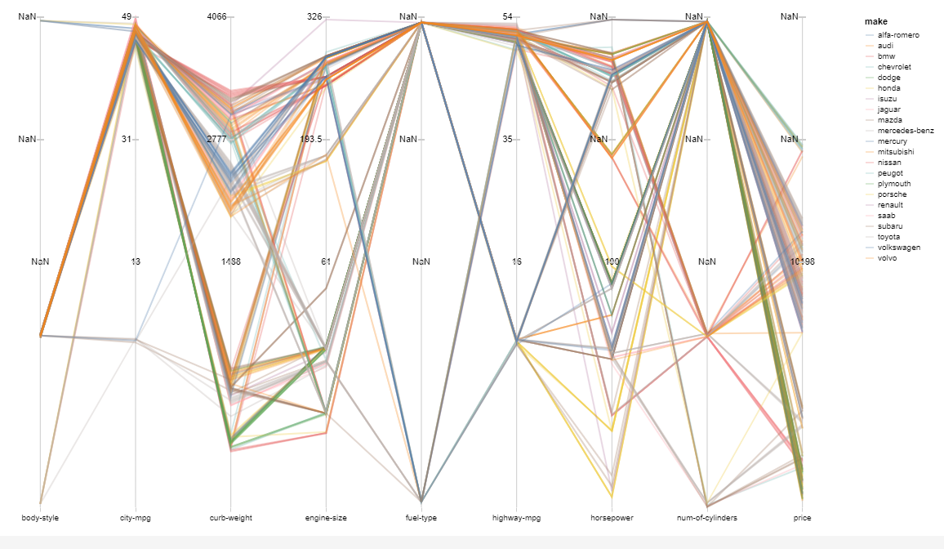

Discussion:

This is a parallel coordinate data visualization for the automobile dataset that was provided. The make of each car is represented by different colors. On the right is a key that shows what color each make corresponds to. The x-axis contains the 9 different attributes that were parsed from the dataset. The y-axis contains the values that corresponds to each attribute. For example, the attribute city-mpg’s max value is 49. A couple of the y-axis displays NaN because the values in the dataset is nominal and it seems like the y-axis can only display quantitative values. However, if the mouse is over the data points, the tooltip will display the correct values.